**-: Lab assignment 1 :-**

1.)retrieve employee names that are getting salary more than 30,000.

2.)find the employee in the order of their salary.

3.)retrieve employee no with their name and city who are living in city other than ‘rajkot’ and ‘baroda’.

**Output :-**

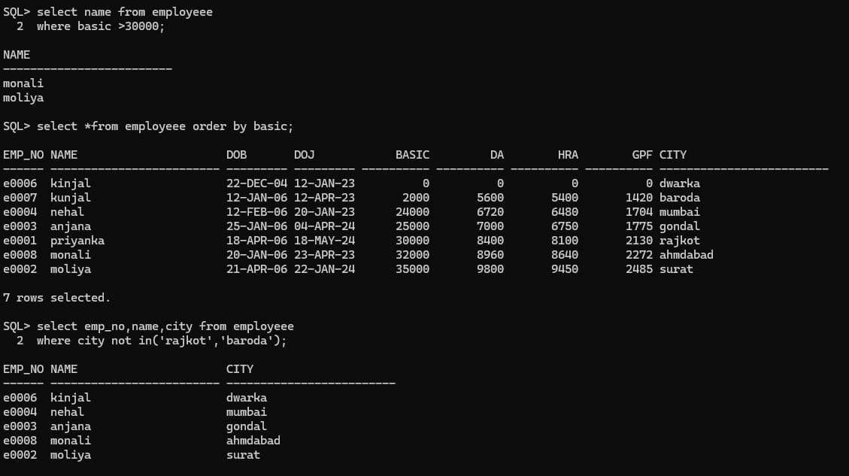

4.)find name of all employee who have noy been paid salary.

5.)retrive employee name,number and city whose name are of minimum of six letters and stsrt with first letter as ‘r’ and third letter as ‘j’.

6.)retrive name of employee who have not opted for HRA.

7.)find name of employees with their total salary.

**Total salary= basic+DA+HRA-GP**

**Output :-**

